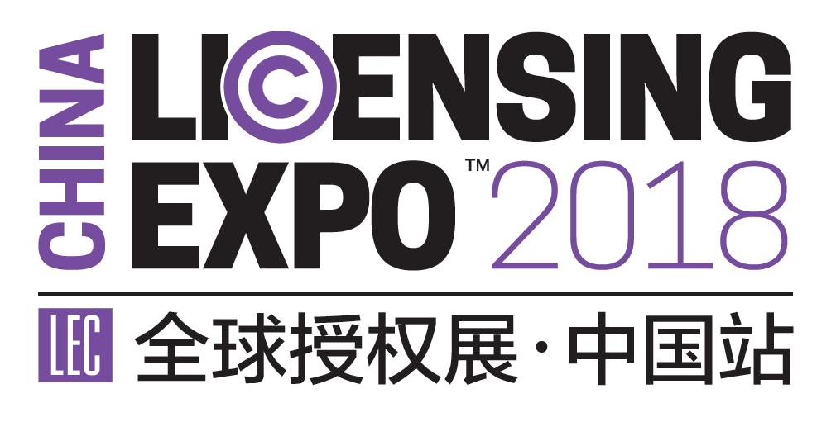

New Exhibitor Application Form
Handled by: ____________
Client Information (Please fill up in block letters or attach business card)
Company Name:
Brand Name:
Contact Person: Department: Title:
Office Number: Mobile:
E-mail: Website:

Reservation Details
□Licensing Expo Japan（ September 13rd to 15th, 2019, Tokyo, Japan）
□ Raw Space ________ sqm □ Standard Booth (9 sqm/booth) _______ booths

□Licensing Expo（May 19th to 21st, 2020, Las Vegas, America）
□ Raw Space ________ sqm □ Standard Booth (9 sqm/booth) _______ booths

□Licensing Expo China（July, 2020， Shanghai, China）
□ Raw Space (Minimum 18 sqm) ________ sqm □ Standard Booth (9 sqm/booth) _______ booths

□Brand Licensing Europe（October 3rd to 5th, 2019, London UK）
□ Raw Space ________ sqm □ Standard Booth (9 sqm/booth) _______ booths

Please send this form to: Amy.Xiao@informa.com

